**Dental Clinic Services System**

Software Requirement Specification

By

**Kanokwan Maneerat 542115002**

**Worapun Wongkium 542115055**

Department of Software Engineering

College of Arts, Media, and Technology

Chiang Mai University

Project Adviser

______________________________

Mrs. Yun Rim Park

**Software Requirement Specification**

**Revision Table**

|  |  |  |  |  |  |
| --- | --- | --- | --- | --- | --- |
| **Document Name** | **Detail** | **Status** | **Date** | **Viewable** | **Reviewer& Responsible** |
| Dental Clinic Services System-SRS-ver 0.1 |  | Draft | 04/06/2014 | Adviser | Kanokwan & Worapun |
| Dental Clinic Services System-SRS-ver 0.2 |  | Draft | 04/26/2014 | Adviser | Kanokwan & Worapun |
|  |  |  |  |  |  |
|  |  |  |  |  |  |
|  |  |  |  |  |  |
|  |  |  |  |  |  |
|  |  |  |  |  |  |

Table of Contents

Chapter One: Introduction 4

1. Introduction 4

1.1 Objectives 4

1.2 Intended Audience and Reading Suggestions 4

1.3 Project Scope 5

Chapter Two: Overall Description 7

2. Overall Description 7

2.1 Product Perspective 7

2.2 Product Features 7

2.3 User Classes and Characteristics 7

2.4 Operation Environment 8

2.5 Design and Implementation Constraints 8

Chapter Three: User Requirement 9

3. User requirement 9

3.1 Dental clinic services system URS 9

3.2 Dental clinic services system SRS 11

Chapter Four: System Features 12

4. System Features 12

4.1 User requirement specification with system requirement specification 12

4.2 Use case diagram.........................................................................................................17

4.3 Use case description 22

# Chapter One: Introduction

## Introduction

### 1.1 Objectives

Dental clinic service system is a web application and mobile application, which support ios7. This application is support English language for the person who is the patient, the officer or the dentist of the dental clinic furthermore it allow visitor can use. This application will reduce officers’ work and do not waste patients’ time so, patient can find anything about dental clinic information or personal information and others from it. For the visitor who want to has a dental treatment from the clinic he/she can make an appointment to the dentist through the application and also the dentist can use it for checking patients’ schedule. The Dental clinic services system is gathered most of the services in the clinic into the web application and mobile application. When the application is grouping all the services together it will be uncomplicated for dental clinic user.

This Software Requirement Specification has described in more detail of each requirement and each function that the system should have. The document includes the scope of project, product function, user characteristic, Functional Requirement, and Non-Functional Requirement.

### 1.2 Intended Audience and Reading Suggestions

### 1.3 Project Scope

The objective of this software requirement specification is to specify requirement to establish the application that:

* Dental clinic services system is application on web and mobile.
* Dental clinic services system on Mobile is android application.
* Dental clinic services system supports English language.
* Dental clinic services system provides for dental clinics’ patient and visitor.
* Dental clinic services system provides the reminder for patient through the application.
* Dental clinic services system provides the QR code that personal information is included
* Dental clinic services system provides the QR code instead the patients’ appointment information
* Dental clinic services system provides the dental information and advertisement.
* Dental clinic services system provides the treatment cost.
* Dental clinic services system following up dental clinics’ patient.
* **1.4Acronyms and Definitions Acronyms**

DCSS =Dental clinic services system

PMP = Project Management Plan

* SDD = Software Design Document
* SRS = Software Requirment Specification
* URS = User Requirement Specification
* SRS = Software Requirement Specification
* UC = Use Case
* AD = Activity Diagram

Definitions Registration information database contains e-mail as username, password, and

display name.

Users database contains information of user which is Email as username, password and display name.

Recipe Details database contains recipe name, recipe description and recipe image Shopping list database contains recipe menu name.

Ingredient item database contains recipe ID, Ingredient ID, Ingredient Amount and ingredient Unit.

Ingredient detail database contains ingredient name, ingredient description and ingredient image

Ingredient store location database contains store location, store name, store description and store image.

Cooking method database contains recipe id, section, cooking method description text and cooking method image.

# 

# Chapter Two: Overall Description

## Overall Description

### 2.1 Product Perspective

The Dental clinic services system is a mobile application base on ios and a web application. So this application helps users save their time to has a contact with the dental clinic by providing features such as First, making an appointment by your own. Second, unnecessary to contain appointment card by using the qr code which that provide by the officer of the clinic for the first time registered. Third, reduce officers’ work that is does not to call to any patient about the appointment. This application is grouping most of dental clinics' services into one application.

### Product Features

The dental clinic services system is divided the feature into six features. Each of features will create a step by a step suit by priority. The following list is a description of each part in more detail.

### 2.3 User Classes and Characteristics

The system divided users into 4 groups. Information and characteristics of each group are listed below.

* **Patient**

This group of person who already register for the system that receives patientID from the dental clinic, they can use the application both in web application and mobile application. Patient uses patientID to login. The patient is able to:

* + Patient can receive the pateintID from the dental clinic
  + Patient can login to the website and the mobile application
  + Patient can make an appointment with dental clinic and also change the appointment date
  + Patient can view their appointment date and details
  + Patient can get the dental information
  + Patient can get the suggestion from the dentist
  + Patient can estimate the dental treatment cost
* **Visitor**

This group of person who cannot login but they can make an appointment. After they confirm they will receive temporary patient from the dental clinic, they can use the application both in web application and mobile application. The visitor is able to:

* + Visitor can view the dentists’ schedule
  + Visitor can get the dental information
  + Visitor can get the suggestion from the dentist
  + Visitor can manage the cost estimation
* **Officer**

This group of person who has the highest privilege in the system. So they gain the management function for maintaining the system. Officer is able to:

* + Officer can login to the system by using officerID
  + Officer can provide the pateintID, dentistID to both users
  + Officer can manage the dental clinic schedule
  + Officer can make the appointment
  + Officer can provide all the information into the database
* **Dentist**

This group of person who has the highest privilege in the system. So they gain the management function for maintaining the system. Dentist is able to:

* + Officer can login to the system by using dentistID
  + Officer can manage the dental clinic schedule
  + Officer can make the appointment

**2.4 Operation Environment**

Server Environment

This system supports windows server platform which capable of web-server, database-server and internet connection. The system also requires at least 10 gigabytes for a database and at least 4 gigabytes of main memory (RAM) for managing with a lot of customer’s session at peak hour.

Client Environment

The system supports only ios platform which capable of internet connection. Patient may need the at least version 7 in order to make the system can run properly.The system also requires at least 1 gigahertz for processor (CPU), at least 16 gigabytes for hard disk space and at least 2 gigabytes of main memory (RAM) for managing with a lot of customer’s session at peak hour.

### 2.5 Design and Implementation Constraints

List of project constraints:

* The application work on only ios version7
* The application is requires the Internet connection.
* The application provides to user who is already registering in the system and also who is not.
* The application has to send the qr code to the dental clinics’ patient and visitor who has an appointment with the clinic

# Chapter Three: User Requirement

## 3. User requirement

### 3.1 Dental clinic services system URS

**Patient**

URS-01: Patient can view the dentist schedule in a website and a mobile application

URS-02: Patient can view the queue in schedule in a website and a mobile application

URS-03: Patient can view his/her appointment in patient schedule in a website and a mobile application

**Officer**

URS-04: Officer can view the dentist schedule

URS-05: Officer can add schedule

URS-06: Officer can edit schedule

URS-07: officer can delete schedule

URS-07: Officer can accept the reservation of the patient

**Dentist**

URS-08: Dentist can view the dentist schedule

URS-09: Dentist can view the patient schedule

URS-10: Dentist can add the schedule

URS-11: Dentist can edit schedule

URS-12: Dentist can delete schedule

URS-12: Dentist can submit the reserving from patients’ request

**Appointment management**

**Patient**

URS-13: Patient can make an appointment by them self

URS-14: Patient can change his/her appointment date

**Officer**

URS-17: Officer can view the patients’ appointment in the schedule

URS-18: Officer can change the patient appointment date

URS-19: Officer can make an appointment date for the patient

URS-20: Officer can cancel an appointment

URS-20: Officer can approve the appointment that patient request

**Dentist**

URS-21: Dentist can view the patients’ appointment in the schedule

URS-22: Dentist can change the patient appointment date

URS-23: Dentist can make an appointment date for the patient

URS-24: Dentist can cancel an appointment

URS-24: Dentist can approve the appointment that patient request

**User registration and authentication**

**Patient**

URS-25: Patient can login to the website and the mobile application by using patient ID

**Officer**

URS-26: Officer can login to the dental clinic website

URS-27: Officer can create the patient account for new patient

URS-28: Officer can create dentist account for dentist

**Dentist**

URS-29: Dentist can login to the dental clinic website

### 3.2 Dental clinic services system SRS

SRS-01: System shall provide the dentist schedule interface in mobile application

SRS-02: System shall provide the dentist schedule interface in website

SRS-03: System shall provide the patient schedule interface in mobile application

SRS-04: System shall provide the patient schedule interface in website

SRS-05: System shall add new schedule in to the database

SRS-06: System shall edit the schedule in the database

SRS-07: System shall delete the schedule in the database

SRS-08: System shall add the patients’ reservation to clinic queue of each day

SRS-09: System shall remove the patients’ queue from the clinic queue

SRS-10: System shall show the patients’ queue in the patients’ schedule

SRS-11: System shall delete the patients’ queue from the patient schedule

SRS-12: System shall send the confirm message to the patient after the reservation is accepted

SRS-13: System shall send the cancel message to the patient after the reservation is cancel

SRS-14: System shall save the reservation into the dentist schedule

SRS-15: System shall provide the patient appointment interface in mobile application

SRS-16: System shall provide the patient appointment interface in website

SRS-17: System shall sent reservation request to the officer

SRS-18: System shall send the reminder of an appointment date to the patient 2 days before the appointment date

SRS-19: System shall sent the reminder of an appointment date to the patient 1 day before the appointment date

SRS-20: System shall sent the reminder of an appointment in the appointment date

SRS-21: System shall send the reminder of an appointment date to the patient in SMS

SRS-22: System shall send the reminder of an appointment date to the patient in email

SRS-23: System shall send the reminder of an appointment date to the patient in QR code

SRS-24: System shall generate the patient reservation information to be a QR code

SRS-25: System shall send the appointment detail in the QR code to the patient via the mobile application and in the email

SRS-26: System shall send changing message to the patient “Sorry, We have to change your appointment date”

SRS-27: System shall provide the login interface in website

SRS-28: System shall check patient ID format the database

SRS-29: System shall check patient ID characters not over 7 characters

SRS-30: System shall check patient password from database

SRS-31: System shall show error message “Wrong username or password”

SRS-32: System shall check ID format the database

SRS-33: System shall check ID characters not over 7 characters

SRS-34: System shall check password from database

SRS-35: System shall show error message “Wrong ID or password”

SRS-36: System shall provide the new patient registration interface in website

SRS-37: System shall generate the patient ID

SRS-38: System shall collect patients’ name, surname, address, telephone number, and email into the database

SRS-39: System shall provide the dentist registration interface in website

SRS-40: System shall generate the ID

SRS-41: System shall collect dentist’ name, surname, address, telephone number, email, and status as a dentist into the database

# Chapter Four: System Features

## 4. System Features

### 4.1 User requirement specification with system requirement specification

**Patient**

URS-01: Patient can view the dentist schedule in a website and a mobile application

SRS-01: System shall provide the dentist schedule interface in mobile application

SRS-02: System shall provide the dentist schedule interface in website

URS-02: Patient can view the queue in schedule in a website and a mobile application

SRS-01: System shall provide the dentist schedule interface in mobile application

SRS-02: System shall provide the dentist schedule interface in website

URS-03: Patient can view his/her appointment in patient schedule in a website and a mobile application

SRS-03: System shall provide the patient schedule interface in mobile application

SRS-04: System shall provide the patient schedule interface in website

**Officer**

URS-04: Officer can view the dentist schedule

SRS-02: System shall provide the dentist schedule interface in website

URS-05: Officer can add/edit/delete schedule

SRS-02: System shall provide the dentist schedule interface in website

SRS-05: System shall add new schedule in to the database

SRS-06: System shall edit the schedule in the database

SRS-07: System shall delete the schedule in the database

URS-06: Officer can manage the patient queue

SRS-08: System shall add the patients’ reservation to clinic queue of each day

SRS-09: System shall remove the patients’ queue from the clinic queue

SRS-10: System shall show the patients’ queue in the patients’ schedule

SRS-11: System shall delete the patients’ queue from the patient schedule

URS-07: Officer can accept the reservation of the patient

SRS-02: System shall provide the dentist schedule interface in website

SRS-12: System shall send the confirm message to the patient after the reservation is accepted

SRS-13: System shall send the cancel message to the patient after the reservation is cancel

SRS-14: System shall save the reservation into the dentist schedule

**Dentist**

URS-08: Dentist can view the dentist schedule

SRS-02: System shall provide the dentist schedule interface in website

URS-09: Dentist can view the patient schedule

SRS-04: System shall provide the patient schedule interface in website

URS-10: Dentist can add/edit/delete the schedule

SRS-02: System shall provide the dentist schedule interface in website

SRS-05: System shall add new schedule in to the database

SRS-06: System shall edit the schedule in the database

SRS-07: System shall delete the schedule in the database

URS-11: Dentist can manage the patients’ queue

SRS-08: System shall add the patients’ reservation to clinic queue of each day

SRS-09: System shall remove the patients’ queue from the clinic queue

SRS-10: System shall show the patients’ queue in the patients’ schedule

SRS-11: System shall delete the patients’ queue from the patient schedule

URS-12: Dentist can submit the reserving from patients’ request

SRS-02: System shall provide the dentist schedule interface in website

SRS-12: System shall send the confirm message to the patient after the reservation is accepted

SRS-13: System shall send the cancel message to the patient after the reservation is cancel

SRS-14: System shall save the reservation into the dentist schedule

**Appointment management**

**Patient**

URS-13: Patient can make an appointment by them self

SRS-01: System shall provide the dentist schedule interface in mobile application

SRS-02: System shall provide the dentist schedule interface in website

SRS-03: System will provide the patient schedule interface in mobile application

SRS-04: System will provide the patient schedule interface in website

SRS-15: System shall provide the patient appointment interface in mobile application

SRS-16: System shall provide the patient appointment interface in website

SRS-17: System shall sent reservation request to the officer

SRS-18: System will provide interface for making an appointment

URS-14: Patient can change his/her appointment date

SRS-01: System shall provide the dentist schedule interface in mobile application

SRS-02: System shall provide the dentist schedule interface in website

SRS-03: System shall provide the patient schedule interface in mobile application

SRS-04: System shall provide the patient schedule interface in website

SRS-15: System shall provide the patient appointment interface in mobile application

SRS-16: System shall provide the patient appointment interface in website

SRS-17: System shall sent reservation request to the officer

SRS-18: System shall provide interface for making an appointment

SRS-…: System shall delete the old reservation from the database

URS-15: Patient can get the reminder of an appointment date

SRS-18: System shall send the reminder of an appointment date to the patient 2 days before the appointment date

SRS-19: System shall sent the reminder of an appointment date to the patient 1 day before the appointment date

SRS-20: System shall sent the reminder of an appointment in the appointment date

SRS-21: System shall send the reminder of an appointment date to the patient in SMS

SRS-22: System shall send the reminder of an appointment date to the patient in email

SRS-23: System shall send the reminder of an appointment date to the patient in QR code

URS-16: New patient can receive the appointment detail in the QR code

SRS-24: System shall generate the patient reservation information to be a QR code

SRS-25: System shall send the appointment detail in the QR code to the patient via the mobile application and in the email

**Officer**

URS-17: Officer can view the patients’ appointment in the schedule

SRS-04: System shall provide the patient schedule interface in website

URS-18: Officer can change the patient appointment date

SRS-02: System shall provide the dentist schedule interface in website

SRS-04: System shall provide the patient schedule interface in website

SRS-16: System shall provide the patient appointment interface in website

SRS-17: System shall sent reservation request to the officer

SRS-18: System shall provide interface for making an appointment

SRS-…: System shall delete the old reservation from the database

SRS-26: System shall send changing message to the patient “Sorry, We have to change your appointment date”

SRS-23: System shall provide the new appointment date in the patient schedule

URS-19: Officer can make an appointment date for the patient

SRS-02: System shall provide the dentist schedule interface in website

SRS-04: System shall provide the patient schedule interface in website

SRS-15: System shall provide the patient appointment interface in mobile application

SRS-16: System shall provide the patient appointment interface in website

SRS-17: System shall sent reservation request to the officer

URS-20: Officer can approve the appointment that patient request

SRS-25: System shall collect the appointment from the patient request to the database

**Dentist**

URS-21: Dentist can view the patients’ appointment in the schedule

SRS-02: System shall provide the patient schedule interface

URS-22: Dentist can change the patient appointment date

SRS-02: System shall provide the patient schedule interface

SRS-19: System shall provide the patient appointment date making interface

SRS-20: System shall collect the patients’ appointment date information in the database

SRS-21: System shall delete the last patients’ appointment date from the patient schedule and in the database

SRS-22: System shall send changing message to the patient “Sorry, We have to change your appointment date”

SRS-23: System shall provide the new appointment date in the patient schedule

URS-23: Dentist can make an appointment date for the patient

SRS-02: System shall provide the patient schedule interface

SRS-19: System shall provide the patient appointment date making interface

SRS-20: System shall collect the patients’ appointment date information in the database

SRS-23: System shall provide the new appointment date in the patient schedule

SRS-24: System shall send the message to the patient “You have an appointment”

URS-24: Dentist can approve the appointment that patient request

SRS-25: System shall collect the appointment from the patient request to the database

**User registration and authentication**

**Patient**

URS-25: Patient can login to the website and the mobile application by using patient ID

SRS-26: System shall provide the login interface in mobile application

SRS-27: System shall provide the login interface in website

SRS-28: System shall check patient ID format the database

SRS-29: System shall check patient ID characters not over 7 characters

SRS-30: System shall check patient password from database

SRS-31: System shall show error message “Wrong username or password”

**Officer**

URS-26: Officer can login to the dental clinic website

SRS-27: System shall provide the login interface in website

SRS-32: System shall check ID format the database

SRS-33: System shall check ID characters not over 7 characters

SRS-34: System shall check password from database

SRS-35: System shall show error message “Wrong ID or password”

URS-27: Officer can create the patient account for new patient

SRS-36: System shall provide the new patient registration interface in website

SRS-37: System shall generate the patient ID

SRS-38: System shall collect patients’ name, surname, address, telephone number, and email into the database

URS-28: Officer can create dentist account for dentist

SRS-39: System shall provide the dentist registration interface in website

SRS-40: System shall generate the ID

SRS-41: System shall collect dentist’ name, surname, address, telephone number, email, and status as a dentist into the database

**Dentist**

URS-29: Dentist can login to the dental clinic website

SRS-27: System shall provide the login interface in website

SRS-32: System shall check ID format the database

SRS-33: System shall check ID characters not over 7 characters

SRS-34: System shall check password from database

SRS-35: System will show error message “Wrong ID or password”

4.2 Use Case  Diagram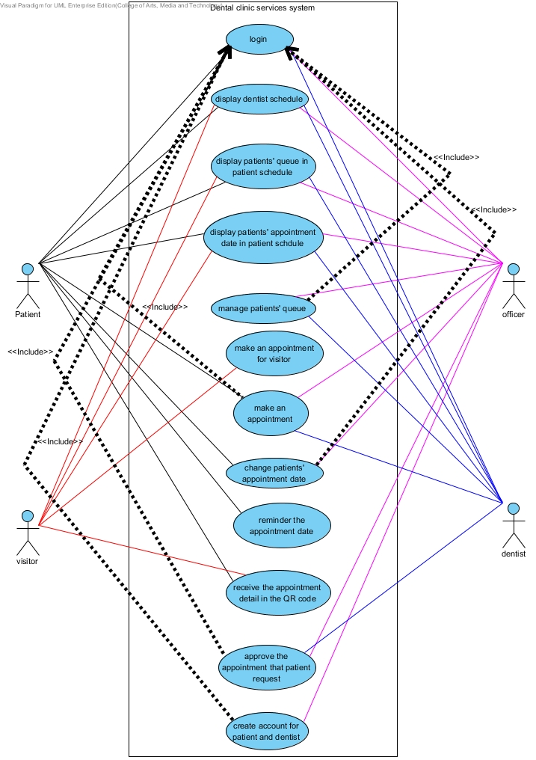

Figure 1: Dental clinic services system use case diagram

**4.2.1 Dental clinic services system Use Case for Patient**

**Patient**

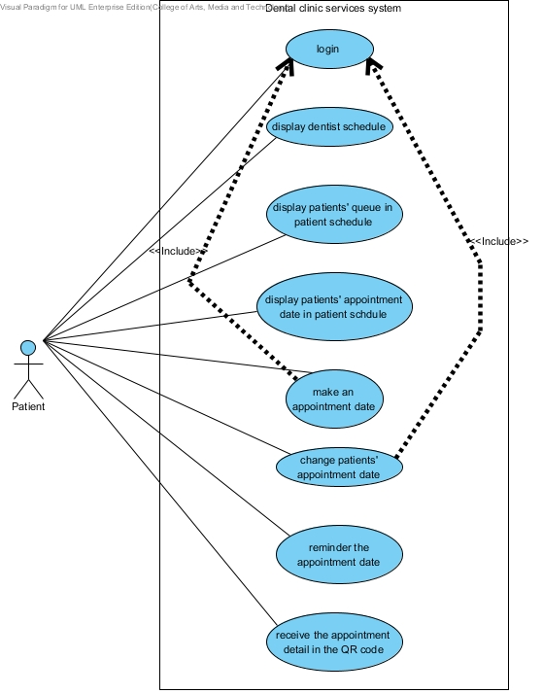

Figure 2: Dental clinic services system patient use case diagram

**4.2.2 Dental clinic services system Use Case for Visitor**

**Visitor**

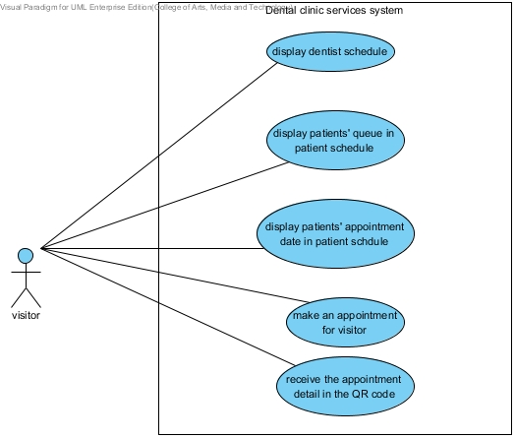

Figure 3: Dental clinic services system visitor use case diagram

**4.2.3 Dental clinic services system Use Case for Officer**

**Officer**

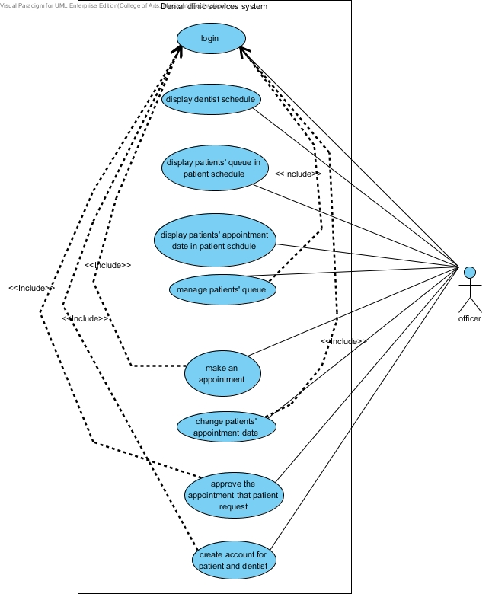

Figure 4: Dental clinic services system officer use case diagram

**4.2.4 Dental clinic services system Use Case for Dentist**

**Dentist**

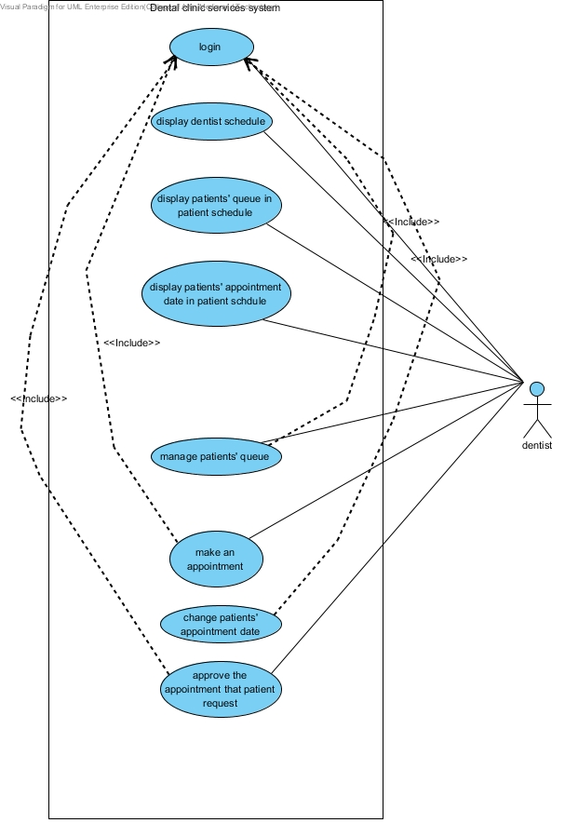

Figure 5 Dental clinic services system dentist use case diagram

### 4.3 Use case description

**4.3.1 Use case description for patient**

|  |  |  |  |
| --- | --- | --- | --- |
| **Use Case ID:** | UC-01 | | |
| **Use Case Name:** | Login | | |
| **Created By:** | Worapun Wongkium | **Last Updated By:** | Worapun Wongkium |
| **Date Created:** | 17/04/2014 | **Last Revision Date:** | 17/04/2014 |
| **Actors:** | Patient | | |
| **Description:** | Patient can login for identifying him/herself to reserve queue for dental treatment and make or change his/her appointment date. | | |
| **Trigger:** | Patient has to enter to the dental clinic services website or application. | | |
| **Preconditions:** | Patient login to the dental clinic website or application. | | |
| **Postconditions:** | Patient login success. | | |
| **Normal Flow:** | 1. Patient enters to website or application.  2. Patient selects to login to the website or application  3. Patient input patient ID and password.  4. System checks the patient ID and password which match in the database.  5. System displays the alert box for success or error message.  6. Patient enters to the application and websites’ home page | | |
| **Alternative Flows:** | 3a.Patient login to the website or application  1.Pateint input patient ID/password  2.Pateint confirm patient/password  3. System validation of the username/password combination fails due to incorrect entry.  4. System asks the user to re-enter the username/password combination.  5. Go back to basic flow 3. | | |
| **Exceptions:** | System initiated: System unavailable the information will not deliver. If there are no internet connection patient cannot login to the website or the application. System validation finds that the user record does not exist in the database. | | |
| **Includes:** | Steps 1-6 in the normal flow would be required for all types of request for login. | | |
| **Frequency of Use:** | On demand | | |
| **Special Requirements:** | N/A | | |
| **Assumptions:** | Patient understands English language. Patient has to has his/her patient ID and password first. Both of them are provided by the dental clinics’ officer | | |
| **Notes and Issues:** |  | | |

|  |  |  |  |
| --- | --- | --- | --- |
| **Use Case ID:** | UC-02 | | |
| **Use Case Name:** | Display dentist schedule | | |
| **Created By:** | Worapun Wongkium | **Last Updated By:** | Worapun Wongkium |
| **Date Created:** | 17/04/2014 | **Last Revision Date:** | 17/04/2014 |
| **Actors:** | Patient | | |
| **Description:** | Patient can view the dentist schedule to looking for the time that available for making a new appointment date or check the date or time for changing his/her appointment date . | | |
| **Trigger:** | Patient has to enter to the dental clinic services website or application. | | |
| **Preconditions:** | Patient selects dentist schedule | | |
| **Postconditions:** | Patient enters to the dentist schedule page | | |
| **Normal Flow:** | 1. Patient enters to website or application.  2. Patient selects dentist schedule  3. Patient view the dentist schedule  4. System displays the dentist schedule on the web page or application.  5. System displays the information in the dentist schedule | | |
| **Alternative Flows:** | N/A | | |
| **Exceptions:** | System initiated: System unavailable the information will not deliver. If there are no internet connection patient cannot login to the website or the application. | | |
| **Includes:** | Steps 1-5 in the normal flow would be required for all types of request for view the dentist schedule. | | |
| **Frequency of Use:** | On demand | | |
| **Special Requirements:** | N/A | | |
| **Assumptions:** | Patient understands English language. Patient has to has his/her patient ID and password first. Both of them are provided by the dental clinics’ officer | | |
| **Notes and Issues:** | N/A | | |

|  |  |  |  |
| --- | --- | --- | --- |
| **Use Case ID:** | UC-03 | | |
| **Use Case Name:** | Display patients’ queue in the patient schedule | | |
| **Created By:** | Worapun Wongkium | **Last Updated By:** | Worapun Wongkium |
| **Date Created:** | 17/04/2014 | **Last Revision Date:** | 17/04/2014 |
| **Actors:** | Patient | | |
| **Description:** | Patient can view his/her queue in the patient schedule to check their own appointment or looking for the time that available for making a new appointment date or check the date or time for changing his/her appointment date. | | |
| **Trigger:** | Patient has to enter to the dental clinic services website or application. | | |
| **Preconditions:** | Patient selects patients’ queue date in the patient schedule | | |
| **Postconditions:** | Patient enters to the patient schedule page | | |
| **Normal Flow:** | 1. Patient enters to website or application.  2. Patient selects patient schedule.  3. Patient views the queue in the patient schedule.  4. System displays the patient schedule on the web page or application.  5. System displays the information in the patient schedule. | | |
| **Alternative Flows:** | N/A | | |
| **Exceptions:** | System initiated: System unavailable the information will not deliver. If there are no internet connection patient cannot login to the website or the application. | | |
| **Includes:** | Steps 1-5 in the normal flow would be required for all types of request for view the patient schedule. | | |
| **Frequency of Use:** | On demand | | |
| **Special Requirements:** | N/A | | |
| **Assumptions:** | Patient understands English language. Patient has to has his/her patient ID and password first. Both of them are provided by the dental clinics’ officer | | |
| **Notes and Issues:** | N/A | | |

|  |  |  |  |
| --- | --- | --- | --- |
| **Use Case ID:** | UC-04 | | |
| **Use Case Name:** | Display patients’ appointment date in the patient schedule | | |
| **Created By:** | Worapun Wongkium | **Last Updated By:** | Worapun Wongkium |
| **Date Created:** | 17/04/2014 | **Last Revision Date:** | 17/04/2014 |
| **Actors:** | Patient | | |
| **Description:** | Patient can view his/her appointment date in their own schedule to check their own appointment or looking for the time that available for making a new appointment date or check the date or time for changing his/her appointment date. | | |
| **Trigger:** | Patient has to enter to the dental clinic services website or application. | | |
| **Preconditions:** | Patient selects patients’ appointment date in the patient schedule | | |
| **Postconditions:** | Patient enters to the patient schedule page | | |
| **Normal Flow:** | 1. Patient enters to website or application.  2. Patient selects patient schedule.  3. Patient views the appointment in the patient schedule.  4. System displays the patient schedule on the web page or application.  5. System displays the information in the patient schedule. | | |
| **Alternative Flows:** | N/A | | |
| **Exceptions:** | System initiated: System unavailable the information will not deliver. If there are no internet connection patient cannot login to the website or the application. | | |
| **Includes:** | Steps 1-5 in the normal flow would be required for all types of request for view the patient schedule. | | |
| **Frequency of Use:** | On demand | | |
| **Special Requirements:** | N/A | | |
| **Assumptions:** | Patient understands English language. Patient has to has his/her patient ID and password first. Both of them are provided by the dental clinics’ officer | | |
| **Notes and Issues:** | N/A | | |

|  |  |  |  |
| --- | --- | --- | --- |
| **Use Case ID:** | UC-05 | | |
| **Use Case Name:** | Make an appointment date | | |
| **Created By:** | Worapun Wongkium | **Last Updated By:** | Worapun Wongkium |
| **Date Created:** | 17/04/2014 | **Last Revision Date:** | 17/04/2014 |
| **Actors:** | Patient | | |
| **Description:** | Patient can making his/her own appointment date. She/he can check the available time from the patient and dentist schedule and confirm to make the appointment. | | |
| **Trigger:** | Patient has to login first | | |
| **Preconditions:** | Patient selects make an appointment date | | |
| **Postconditions:** | Patient enters to the make an appointment page | | |
| **Normal Flow:** | 1. Patient enters to website or application.  2. Patient selects patient/dentist schedule.  3. Patient views the appointment in the patient schedule.  4. System displays the patient/dentist schedule on the web page or application.  5. System displays the information in the patient/dentist schedule.  7. Patient selects make an appointment date  8. Patient selects the time and date which provide in the page and input the symptom description  9. System validates the date and time from patients’ request does available or not.  10. System collects the information in the database  11. System sends the confirmation via patients’ email  12. Patient confirms to make a new appointment date.  13. System collect the information in to the database  14. System sends the QR code and email of the appointment to the patient  15. System updates patient and dentist schedule | | |
| **Alternative Flows:** | 8a.Patient confirm to make a new appointment date  1.Pateint receive the message about confirmation from dental clinic  2. System validation of the date and time from patient request fails due to an incorrect entry.  4. System asks the user to re-enter the date and time or cancel  5. Go back to basic flow 8. | | |
| **Exceptions:** | System initiated: System unavailable the information will not deliver. If there are no internet connection patient cannot login to the website or the application. | | |
| **Includes:** | Steps 1-15 in the normal flow would be required for all types of make an appointment date | | |
| **Frequency of Use:** | On demand | | |
| **Special Requirements:** | N/A | | |
| **Assumptions:** | Patient understands or English language. Patient has to have his/her patient ID and password first. Both of them are provided by the dental clinics’ officer. | | |
| **Notes and Issues:** | N/A | | |

|  |  |  |  |
| --- | --- | --- | --- |
| **Use Case ID:** | UC-06 | | |
| **Use Case Name:** | Change patients’ appointment date | | |
| **Created By:** | Worapun Wongkium | **Last Updated By:** | Worapun Wongkium |
| **Date Created:** | 17/04/2014 | **Last Revision Date:** | 17/04/2014 |
| **Actors:** | Patient | | |
| **Description:** | Patient can making his/her own appointment date and also change the appointment date so, the last appointment date is removed from the patient and dentist schedule | | |
| **Trigger:** | Patient has to login first | | |
| **Preconditions:** | Patient selects patient schedule | | |
| **Postconditions:** | Patient enters to the patient schedule | | |
| **Normal Flow:** | 1. Patient enters to website or application.  2. Patient selects patient/dentist schedule.  3. Patient views the appointment in the patient schedule.  4. System displays the patient/dentist schedule on the web page or application.  5. System displays the information in the patient/dentist schedule.  7. Patient selects the date that he/she wants to change in the patients’ schedule  8. System displays the information of the appointment that patient select  9. Patient selects the time and date which provide in the page to change the appointment date  10. System validates the date and time from patients’ request does available or not.  11. System collects the information in the database  12. System sends the confirmation via patients’ email  13. Patient confirms to make a new appointment date.  14. System collect the information in to the database  15. System sends the QR code and email of the appointment to the patient  16. System updates patient and dentist schedule | | |
| **Alternative Flows:** | 8a.Patient confirm to make a new appointment date  1.Pateint receive the message about confirmation from dental clinic  2. System validation of the date and time from patient request fails due to an incorrect entry.  4. System asks the user to re-enter the date and time or cancel  5. Go back to basic flow 8. | | |
| **Exceptions:** | System initiated: System unavailable the information will not deliver. If there are no internet connection patient cannot login to the website or the application. | | |
| **Includes:** | Steps 1-16 in the normal flow would be required for all types of change appointment date | | |
| **Frequency of Use:** | On demand | | |
| **Special Requirements:** | N/A | | |
| **Assumptions:** | Patient understands English language. Patient has to have his/her patient ID and password first. Both of them are provided by the dental clinics’ officer. | | |
| **Notes and Issues:** | N/A | | |

|  |  |  |  |
| --- | --- | --- | --- |
| **Use Case ID:** | UC-07 | | |
| **Use Case Name:** | Reminder the appointment date | | |
| **Created By:** | Worapun Wongkium | **Last Updated By:** | Worapun Wongkium |
| **Date Created:** | 17/04/2014 | **Last Revision Date:** | 17/04/2014 |
| **Actors:** | Patient | | |
| **Description:** | Patient can receive the reminder of the appointment date from the dental clinic through the email,message,application | | |
| **Trigger:** | Patient has to enter to the dental clinic services website or application. | | |
| **Preconditions:** | Patient has to enter to the dental clinic services website or application. | | |
| **Postconditions:** | Patient has to enter to the dental clinic services website or application. | | |
| **Normal Flow:** | 1. Patient enters to website or application.  2. Patient receive the reminder about the appointment date  3. Patient views the appointment date information before the due date.  4. System sends the reminder two days before the appointment date arrive  5. System sends the reminder two days before the appointment date via the message,email,application | | |
| **Alternative Flows:** | N/A | | |
| **Exceptions:** | System initiated: System unavailable the information will not deliver. If there are no internet connection patient cannot login to the website or the application. | | |
| **Includes:** | Steps 1-5 in the normal flow would be required for all types of remind the patients’ appointment date | | |
| **Frequency of Use:** | On demand | | |
| **Special Requirements:** | N/A | | |
| **Assumptions:** | Patient understands English language. Patient has to have his/her patient ID and password first. Both of them are provided by the dental clinics’ officer. | | |
| **Notes and Issues:** | N/A | | |

|  |  |  |  |
| --- | --- | --- | --- |
| **Use Case ID:** | UC-08 | | |
| **Use Case Name:** | Receive the appointment date in the QR code | | |
| **Created By:** | Worapun Wongkium | **Last Updated By:** | Worapun Wongkium |
| **Date Created:** | 17/04/2014 | **Last Revision Date:** | 17/04/2014 |
| **Actors:** | Patient | | |
| **Description:** | Patient can receive the appointment information in the QR code after make a confirmation with the dental clinics’ officer. | | |
| **Trigger:** | Patient has to enter to the dental clinic services website or application. | | |
| **Preconditions:** | Patient has to enter to the dental clinic services website or application. | | |
| **Postconditions:** | Patient has to enter to the dental clinic services website or application. | | |
| **Normal Flow:** | 1. Patient enters to website or application.  2. Patient receives the QR code about the appointment date after make a new appointment date.  3. Patient receives the QR code about the appointment date after make a confirmation with the officer  4. System collects the appointment information into the database  5. System generates the patients ‘appointment information into the QR code.  6. System sends the QR code to the patient | | |
| **Alternative Flows:** | N/A | | |
| **Exceptions:** | System initiated: System unavailable the information will not deliver. If there are no internet connection patient cannot login to the website or the application. | | |
| **Includes:** | Steps 1-6 in the normal flow would be required for all types of receive the appointment in the QR code | | |
| **Frequency of Use:** | On demand | | |
| **Special Requirements:** | N/A | | |
| **Assumptions:** | Patient understands English language. Patient has to have his/her patient ID and password first. Both of them are provided by the dental clinics’ officer. | | |
| **Notes and Issues:** | N/A | | |

**4.3.2 Use case description for visitor**

|  |  |  |  |
| --- | --- | --- | --- |
| **Use Case ID:** | UC-09 | | |
| **Use Case Name:** | Display dentist schedule | | |
| **Created By:** | Worapun Wongkium | **Last Updated By:** | Worapun Wongkium |
| **Date Created:** | 17/04/2014 | **Last Revision Date:** | 17/04/2014 |
| **Actors:** | Visitor | | |
| **Description:** | Visitor can view the dentist schedule to looking for the time that available for making a new appointment date or check the date or time for changing his/her appointment date . | | |
| **Trigger:** | Visitor has to enter to the dental clinic services website or application. | | |
| **Preconditions:** | Visitor selects dentist schedule | | |
| **Postconditions:** | Visitor enters to the dentist schedule page | | |
| **Normal Flow:** | 1. Visitor enters to website or application.  2. Visitor selects dentist schedule  3. Visitor view the dentist schedule  4. System displays the dentist schedule on the web page or application.  5. System displays the information in the dentist schedule | | |
| **Alternative Flows:** | N/A | | |
| **Exceptions:** | System initiated: System unavailable the information will not deliver. If there are no internet connection patient cannot login to the website or the application. | | |
| **Includes:** | Steps 1-5 in the normal flow would be required for all types of request for view the dentist schedule. | | |
| **Frequency of Use:** | On demand | | |
| **Special Requirements:** | N/A | | |
| **Assumptions:** | Visitor understands English language. | | |
| **Notes and Issues:** | N/A | | |

|  |  |  |  |
| --- | --- | --- | --- |
| **Use Case ID:** | UC-10 | | |
| **Use Case Name:** | Display patients’ queue in the patient schedule | | |
| **Created By:** | Worapun Wongkium | **Last Updated By:** | Worapun Wongkium |
| **Date Created:** | 17/04/2014 | **Last Revision Date:** | 17/04/2014 |
| **Actors:** | Visitor | | |
| **Description:** | Visitor can view other patients’ queue in the patient schedule to check the appointment date/time to looking for the time that available for making a new appointment date. | | |
| **Trigger:** | Visitor has to enter to the dental clinic services website or application. | | |
| **Preconditions:** | Visitor selects patients’ queue date in the patient schedule | | |
| **Postconditions:** | Visitor enters to the patient schedule page | | |
| **Normal Flow:** | 1. Visitor enters to website or application.  2. Visitor selects patient schedule.  3. Visitor views the queue in the patient schedule.  4. System displays the patient schedule on the web page or application.  5. System displays the information in the patient schedule. | | |
| **Alternative Flows:** | N/A | | |
| **Exceptions:** | System initiated: System unavailable the information will not deliver. If there are no internet connection patient cannot login to the website or the application. | | |
| **Includes:** | Steps 1-5 in the normal flow would be required for all types of request for view the patient schedule. | | |
| **Frequency of Use:** | On demand | | |
| **Special Requirements:** | N/A | | |
| **Assumptions:** | Visitor understands English language. | | |
| **Notes and Issues:** | N/A | | |

|  |  |  |  |
| --- | --- | --- | --- |
| **Use Case ID:** | UC-11 | | |
| **Use Case Name:** | Display patients’ appointment date in the patient schedule | | |
| **Created By:** | Worapun Wongkium | **Last Updated By:** | Worapun Wongkium |
| **Date Created:** | 17/04/2014 | **Last Revision Date:** | 17/04/2014 |
| **Actors:** | Visitor | | |
| **Description:** | Visitor can view patients’ appointment date in the patient schedule to check date and time which is available for making a new appointment | | |
| **Trigger:** | Visitor has to enter to the dental clinic services website or application. | | |
| **Preconditions:** | Visitor selects patients’ appointment date in the patient schedule | | |
| **Postconditions:** | Visitor enters to the patient schedule page | | |
| **Normal Flow:** | 1. Visitor enters to website or application.  2. Visitor selects patient schedule.  3. Visitor views the appointment in the patient schedule.  4. System displays the patient schedule on the web page or application.  5. System displays the information in the patient schedule. | | |
| **Alternative Flows:** | N/A | | |
| **Exceptions:** | System initiated: System unavailable the information will not deliver. If there are no internet connection patient cannot login to the website or the application. | | |
| **Includes:** | Steps 1-5 in the normal flow would be required for all types of request for view the patient schedule. | | |
| **Frequency of Use:** | On demand | | |
| **Special Requirements:** | N/A | | |
| **Assumptions:** | Visitor understands English language. | | |
| **Notes and Issues:** | N/A | | |

|  |  |  |  |
| --- | --- | --- | --- |
| **Use Case ID:** | UC-12 | | |
| **Use Case Name:** | Make an appointment for visitor | | |
| **Created By:** | Worapun Wongkium | **Last Updated By:** | Worapun Wongkium |
| **Date Created:** | 17/04/2014 | **Last Revision Date:** | 17/04/2014 |
| **Actors:** | Visitor | | |
| **Description:** | Visitor can making his/her own appointment date. She/he can check the available time from the patient and dentist schedule and confirm to make the appointment. | | |
| **Trigger:** | Visitor has to enter to the website or the application | | |
| **Preconditions:** | Visitor selects make an appointment date | | |
| **Postconditions:** | Visitor enters to the make an appointment page | | |
| **Normal Flow:** | 1. Visitor enters to website or application.  2. Visitor selects patient/dentist schedule.  3. Visitor views the appointment in the patient schedule.  4. System displays the patient/dentist schedule on the web page or application.  5. System displays the information in the patient/dentist schedule.  7. Visitor selects make an appointment date  8. Visitor selects the time and date which provide in the page and input the symptom description  9. System validates the date and time from patients’ request does available or not.  10. System collects the information in the database  11. System sends the confirmation via patients’ email  12. Visitor confirms to make a new appointment date.  13. System collect the information in to the database  14. System sends the QR code and email of the appointment to the patient  15. System updates patient and dentist schedule | | |
| **Alternative Flows:** | 8a. Visitor confirm to make a new appointment date  1. Visitor receive the message about confirmation from dental clinic  2. System validation of the date and time from patient request fails due to an incorrect entry.  4. System asks the user to re-enter the date and time or cancel  5. Go back to basic flow 8. | | |
| **Exceptions:** | System initiated: System unavailable the information will not deliver. If there are no internet connection patient cannot login to the website or the application. | | |
| **Includes:** | Steps 1-15 in the normal flow would be required for all types of make an appointment date | | |
| **Frequency of Use:** | On demand | | |
| **Special Requirements:** | N/A | | |
| **Assumptions:** | Visitor understands English language. | | |
| **Notes and Issues:** | N/A | | |

|  |  |  |  |
| --- | --- | --- | --- |
| **Use Case ID:** | UC-13 | | |
| **Use Case Name:** | Receive the appointment date in the QR code | | |
| **Created By:** | Worapun Wongkium | **Last Updated By:** | Worapun Wongkium |
| **Date Created:** | 17/04/2014 | **Last Revision Date:** | 17/04/2014 |
| **Actors:** | Visitor | | |
| **Description:** | Visitor can receive the appointment information in the QR code after make a confirmation with the dental clinics’ officer. | | |
| **Trigger:** | Visitor has to enter to the dental clinic services website or application. | | |
| **Preconditions:** | Visitor has to enter to the dental clinic services website or application. | | |
| **Postconditions:** | Visitor has to enter to the dental clinic services website or application. | | |
| **Normal Flow:** | 1. Visitor enters to website or application.  2. Visitor receives the QR code about the appointment date after make a new appointment date.  3. Visitor receives the QR code about the appointment date after make a confirmation with the officer  4. System collects the appointment information into the database  5. System generates the patients ‘appointment information into the QR code.  6. System sends the QR code to the patient | | |
| **Alternative Flows:** | N/A | | |
| **Exceptions:** | System initiated: System unavailable the information will not deliver. | | |
| **Includes:** | Steps 1-6 in the normal flow would be required for all types of receive the appointment in the QR code | | |
| **Frequency of Use:** | On demand | | |
| **Special Requirements:** | N/A | | |
| **Assumptions:** | Visitor understands English language. | | |
| **Notes and Issues:** | N/A | | |

|  |  |  |  |
| --- | --- | --- | --- |
| **Use Case ID:** | UC-14 | | |
| **Use Case Name:** | Login | | |
| **Created By:** | Kaokwan Maneerat | **Last Updated By:** | Kanokwan Maneerat |
| **Date Created:** | 17/04/2014 | **Last Revision Date:** | 26/04/2014 |
| **Actors:** | Officer, Dentist | | |
| **Description:** | Officer and dentist can login for identifying him/herself to manage the services in web application | | |
| **Trigger:** | Click ‘Officer/Dentist Login’ button | | |
| **Preconditions:** | Officer need to enter the website first | | |
| **Postconditions:** | Login successful. | | |
| **Normal Flow:** | 1. Officer/Dentist input username and password  2. Press ‘login’ button  3. System check the username and password which match in the database  4. System checks the priority of user by role which are officer or dentist  5. System displays the alert box for success or error message  6. System automatically open the home page of website | | |
| **Alternative Flows:** | 3a. username or password or both are not match in the database  1. System validate the username/password combination fails due to incorrect entry.  4. System show the error message that username or password are not correct  5. Go back to login page. | | |
| **Exceptions:** | System initiated: System unavailable the information will not deliver. If there are no internet connection user cannot login to the website or the application. System validation finds that the user record does not exist in the database. | | |
| **Includes:** | Steps 1-6 in the normal flow would be required for all types of request for login. | | |
| **Frequency of Use:** | On demand | | |
| **Special Requirements:** | N/A | | |
| **Assumptions:** | Officer and dentist understands English language. | | |
| **Notes and Issues:** | N/A | | |

|  |  |  |  |
| --- | --- | --- | --- |
| **Use Case ID:** | UC-15 | | |
| **Use Case Name:** | Display the dentists’ schedule | | |
| **Created By:** | Kaokwan Maneerat | **Last Updated By:** | Kanokwan Maneerat |
| **Date Created:** | 17/04/2014 | **Last Revision Date:** | 26/04/2014 |
| **Actors:** | Officer, Dentist | | |
| **Description:** | Display the dentists’ schedule. Officer and dentist can manage their schedule after this usecase | | |
| **Trigger:** | Click ‘View schedule’ button | | |
| **Preconditions:** | Officer and dentist need to login the website first | | |
| **Postconditions:** | N/A | | |
| **Normal Flow:** | 1. Dentists’ schedule displayed | | |
| **Alternative Flows:** | N/A | | |
| **Exceptions:** | N/A | | |
| **Includes:** | N/A | | |
| **Frequency of Use:** | On demand | | |
| **Special Requirements:** | N/A | | |

|  |  |  |  |
| --- | --- | --- | --- |
| **Use Case ID:** | UC-16 | | |
| **Use Case Name:** | Display patients’ queue | | |
| **Created By:** | Kaokwan Maneerat | **Last Updated By:** | Kanokwan Maneerat |
| **Date Created:** | 17/04/2014 | **Last Revision Date:** | 26/04/2014 |
| **Actors:** | Officer, Dentist | | |
| **Description:** | Display patients’ queue in the patient schedule | | |
| **Trigger:** | Click ‘View schedule’ button | | |
| **Preconditions:** | Officer and dentist need to login the website first | | |
| **Postconditions:** | N/A | | |
| **Normal Flow:** | 1. Provide the patients’ queue in details of an appointment | | |
| **Alternative Flows:** | N/A | | |
| **Exceptions:** | N/A | | |
| **Includes:** | N/A | | |
| **Frequency of Use:** | On demand | | |
| **Special Requirements:** | N/A | | |
| **Assumptions:** | Officer and dentist understands English language. | | |
| **Notes and Issues:** | N/A | | |

|  |  |  |  |
| --- | --- | --- | --- |
| **Use Case ID:** | UC-17 | | |
| **Use Case Name:** | Display patients’ appointment | | |
| **Created By:** | Kaokwan Maneerat | **Last Updated By:** | Kanokwan Maneerat |
| **Date Created:** | 17/04/2014 | **Last Revision Date:** | 26/04/2014 |
| **Actors:** | Officer, Dentist | | |
| **Description:** | Display patients’ queue in the patient schedule | | |
| **Trigger:** | Click ‘View schedule’ button | | |
| **Preconditions:** | Officer and dentist need to login the website first | | |
| **Postconditions:** | N/A | | |
| **Normal Flow:** | 1. Provide the patients’ queue in details of an appointment | | |
| **Alternative Flows:** | N/A | | |
| **Exceptions:** | N/A | | |
| **Includes:** | N/A | | |
| **Frequency of Use:** | On demand | | |
| **Special Requirements:** | N/A | | |
| **Assumptions:** | Officer and dentist understands English language. | | |
| **Notes and Issues:** | N/A | | |

|  |  |  |  |
| --- | --- | --- | --- |
| **Use Case ID:** | UC-18 | | |
| **Use Case Name:** | Manage patients’ queue | | |
| **Created By:** | Kaokwan Maneerat | **Last Updated By:** | Kanokwan Maneerat |
| **Date Created:** | 17/04/2014 | **Last Revision Date:** | 26/04/2014 |
| **Actors:** | Officer, Dentist | | |
| **Description:** | Manage the patients’ queue which is add, change, and delete the queue | | |
| **Trigger:** | Click ‘Manage Queue’ button | | |
| **Preconditions:** | Officer and dentist need to login the website first | | |
| **Postconditions:** | Patients’ queue update after press confirm button | | |
| **Normal Flow:** | 1. System collect all the patients in each day to generate the queue for that day 2. The queue of each day show in the schedule 3. Manage the queue 4. Press confirm button | | |
| **Alternative Flows:** | 3a. Add new queue   1. Press ‘add new queue’ to add the new queue 2. Input name and patient ID   3b. Delete queue   1. Press at any queue 2. Delete button will appear 3. Press delete | | |
| **Exceptions:** | N/A | | |
| **Includes:** | N/A | | |
| **Frequency of Use:** | On demand | | |
| **Special Requirements:** | N/A | | |

|  |  |  |  |
| --- | --- | --- | --- |
| **Use Case ID:** | UC-19 | | |
| **Use Case Name:** | Change patients’ appointment date | | |
| **Created By:** | Kaokwan Maneerat | **Last Updated By:** | Kanokwan Maneerat |
| **Date Created:** | 17/04/2014 | **Last Revision Date:** | 26/04/2014 |
| **Actors:** | Officer, Dentist | | |
| **Description:** | Change patients’ appointment date in case of that appointment day clinic has an necessary close or dentist is on emergency case | | |
| **Trigger:** | Click ‘manage appointment’ button | | |
| **Preconditions:** | Officer and dentist need to login the website first | | |
| **Postconditions:** | Patients’ queue update after press confirm button | | |
| **Normal Flow:** | 1. Dentist schedule show up 2. Select the appointment that need to change 3. Edit menu will show up which are edit and delete 4. Press edit 5. Change the appointment date 6. Press ‘confirm’ button | | |
| **Alternative Flows:** | 6a. Press ‘cancel’ button   1. The change of appointment date will not save to the database | | |
| **Exceptions:** | N/A | | |
| **Includes:** | N/A | | |
| **Frequency of Use:** | On demand | | |
| **Special Requirements:** | N/A | | |
| **Assumptions:** | Officer and dentist understands English language. | | |
| **Notes and Issues:** | N/A | | |

|  |  |  |  |
| --- | --- | --- | --- |
| **Use Case ID:** | UC-20 | | |
| **Use Case Name:** | Approve the new appointment that patient request | | |
| **Created By:** | Kaokwan Maneerat | **Last Updated By:** | Kanokwan Maneerat |
| **Date Created:** | 17/04/2014 | **Last Revision Date:** | 26/04/2014 |
| **Actors:** | Officer, Dentist | | |
| **Description:** | Approve the new appointment request of patient when patient wants to change the appointment date or wants to make a new appointment. | | |
| **Trigger:** | Click ‘New request’ button | | |
| **Preconditions:** | Officer and dentist need to login the website first | | |
| **Postconditions:** | New patient added to the database | | |
| **Normal Flow:** | 1. Dentist schedule show up 2. Select at the empty time slot in the schedule 3. Add button will show up 4. Press add 5. Input patients’ id and details 6. Press ‘confirm’ button | | |
| **Alternative Flows:** | 6a. Press ‘cancel’ button   1. The new appointment will not save to the database | | |
| **Exceptions:** | N/A | | |
| **Includes:** | N/A | | |
| **Frequency of Use:** | On demand | | |
| **Special Requirements:** | N/A | | |
| **Assumptions:** | Officer and dentist understands English language. | | |
| **Notes and Issues:** | N/A | | |

|  |  |  |  |
| --- | --- | --- | --- |
| **Use Case ID:** | UC-21 | | |
| **Use Case Name:** | Create account for patient | | |
| **Created By:** | Kaokwan Maneerat | **Last Updated By:** | Kanokwan Maneerat |
| **Date Created:** | 17/04/2014 | **Last Revision Date:** | 26/04/2014 |
| **Actors:** | Officer | | |
| **Description:** | Create account for dentist to login to use the services | | |
| **Trigger:** | Click ‘New dentist’ button | | |
| **Preconditions:** | Officer need to login the website first | | |
| **Postconditions:** | New appointment added to the schedule | | |
| **Normal Flow:** | 1. Registration form appear 2. Input all require data 3. Press ‘Register’ button 4. System will check the patients’ name, surname and email that are already exist or not 5. Confirm message or error message will show up | | |
| **Alternative Flows:** | 4a. The account already exist  5a. Alert message will show up that account already exist | | |
| **Exceptions:** | N/A | | |
| **Includes:** | N/A | | |
| **Frequency of Use:** | On demand | | |
| **Special Requirements:** | N/A | | |
| **Assumptions:** | Officer understands English language. | | |
| **Notes and Issues:** | N/A | | |

|  |  |  |  |
| --- | --- | --- | --- |
| **Use Case ID:** | UC-22 | | |
| **Use Case Name:** | Create account for dentist | | |
| **Created By:** | Kaokwan Maneerat | **Last Updated By:** | Kanokwan Maneerat |
| **Date Created:** | 17/04/2014 | **Last Revision Date:** | 26/04/2014 |
| **Actors:** | Officer | | |
| **Description:** | Create account for dentist to login to use the services | | |
| **Trigger:** | Click ‘New dentist’ button | | |
| **Preconditions:** | Officer need to login the website first | | |
| **Postconditions:** | New dentist added to the database | | |
| **Normal Flow:** | 1. Registration form appear 2. Input all require data 3. Press ‘Register’ button 4. System will check the dentist’ name, surname and email that are already exist or not 5. Confirm message or error message will show up | | |
| **Alternative Flows:** | 4a. The account already exist  5a. Alert message will show up that account already exist | | |
| **Exceptions:** | N/A | | |
| **Includes:** | N/A | | |
| **Frequency of Use:** | On demand | | |
| **Special Requirements:** | N/A | | |
| **Assumptions:** | Officer understands English language. | | |
| **Notes and Issues:** | N/A | | |